To copy data of one bucket to another bucket of same account or different account, replication rule is used.

Use following steps for replication rule:

Firstly login to AWS console then open the s3 service

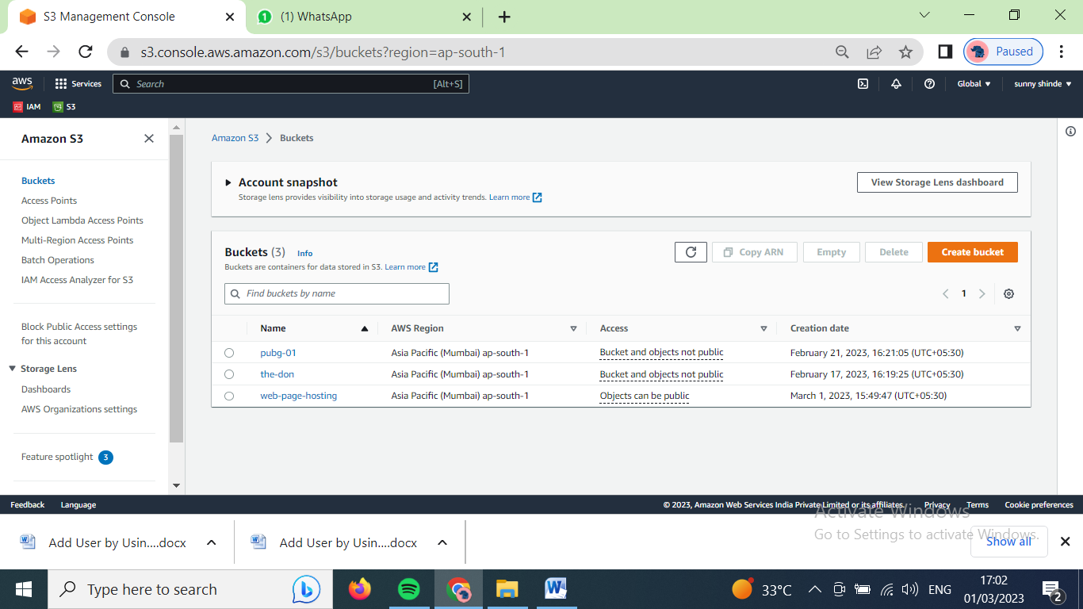

Now lets create replication rule for already existing bucket ‘the-don’

Open the bucket ‘the-don’ by clicking on it.

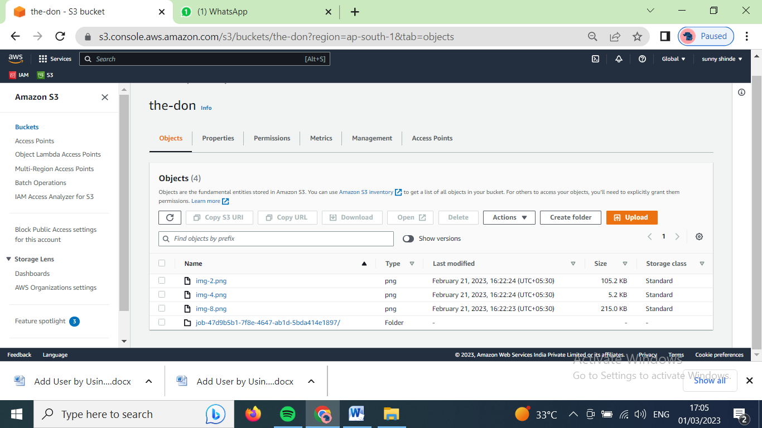

On navigation bar click on management option

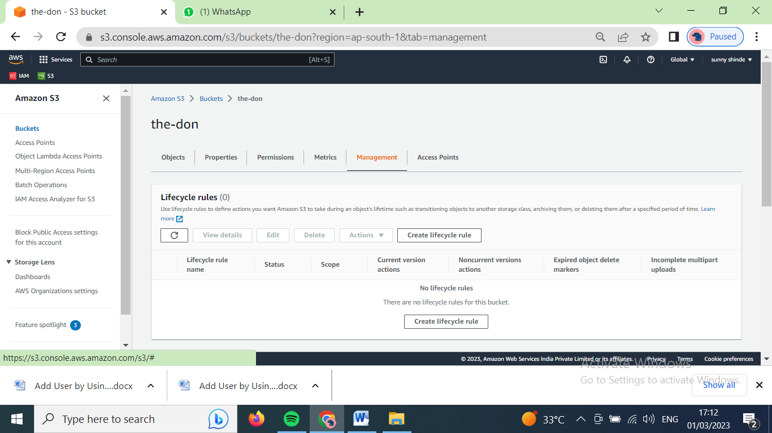

Scroll down

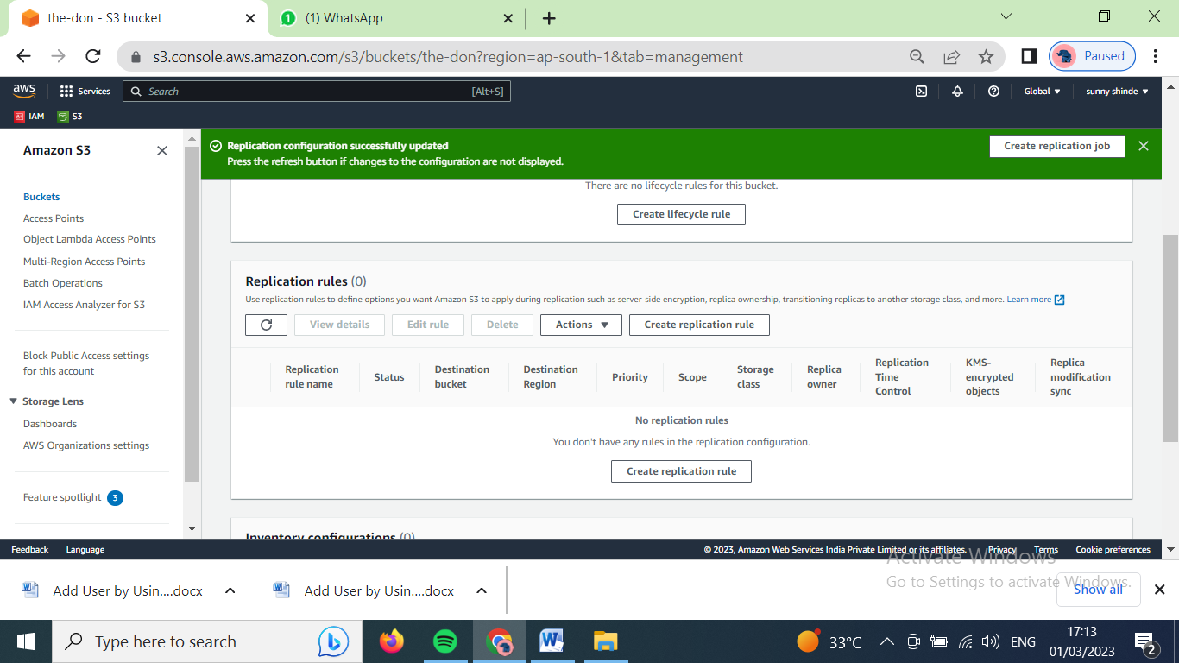

Click on ‘create replication rule’

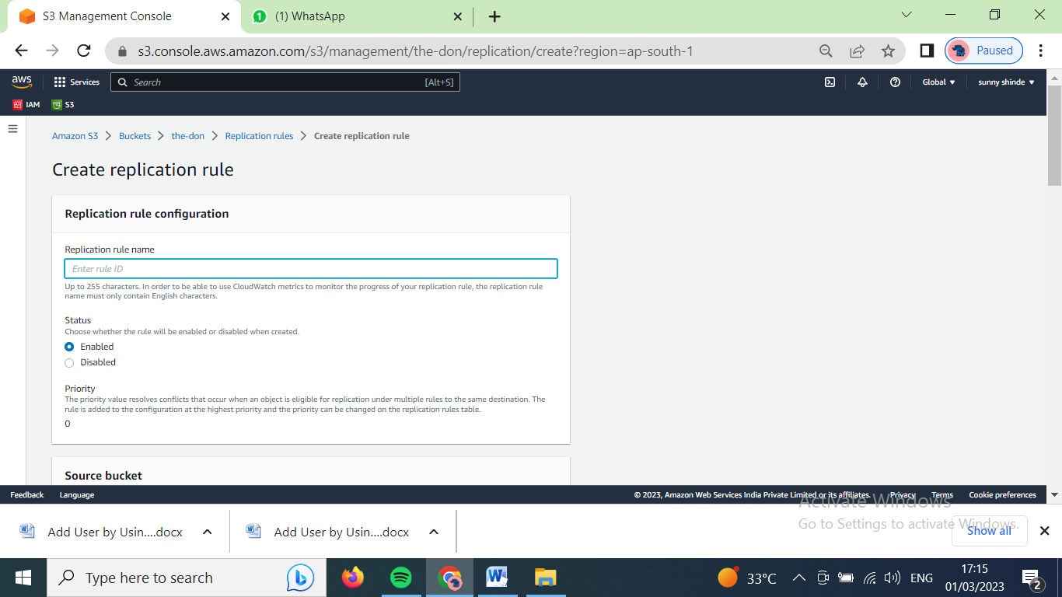

Type the name for replication rule

Scroll down

Choose ‘apply to all objects in the bucket’ for to copy all the data in bucket

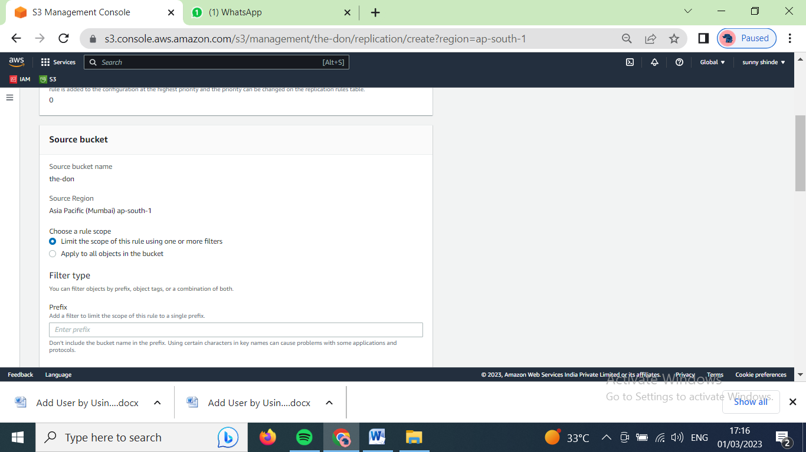

Case 1) to copy data of bucket to another bucket in same account

Select ‘Choose a bucket in this account’

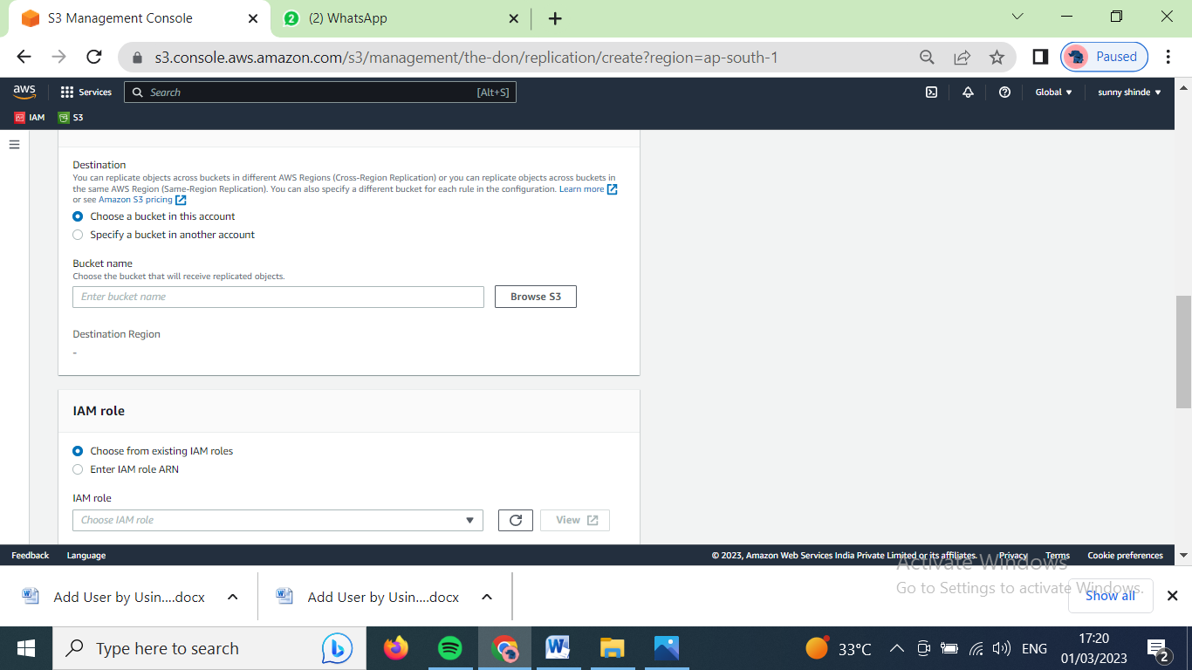

Click on browse s3 to select the bucket in which we want to copy our data

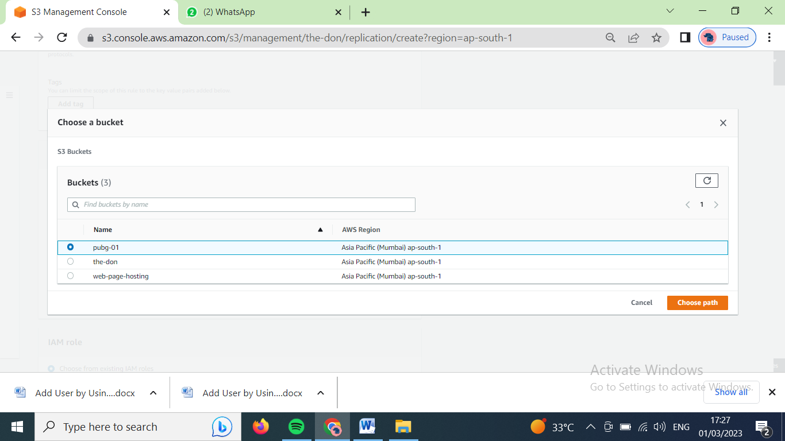

Click on choose path. Select on ‘create new role’ in IAM role option.

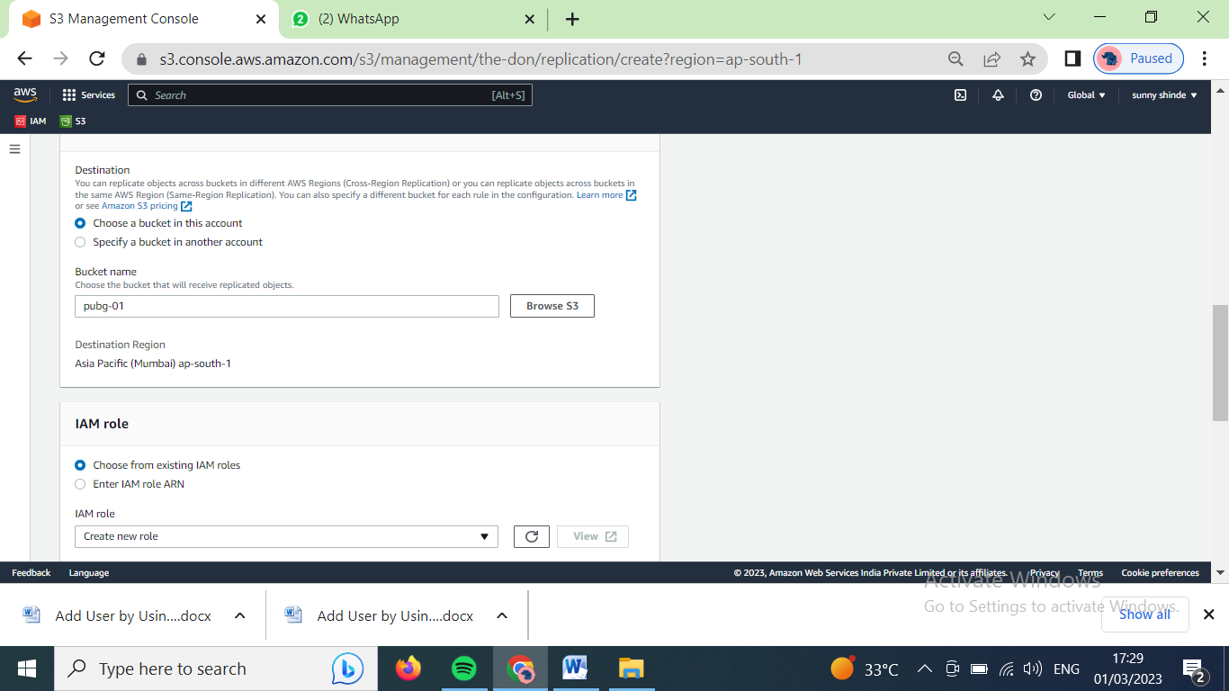

Scroll down and click on save changes

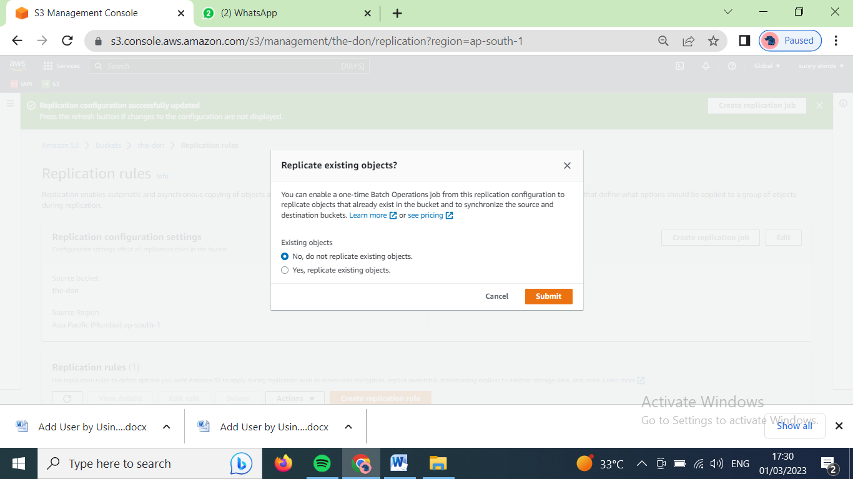

Select on ‘yes, replicate existing objects’. Click on submit button.

After that replication rule is created and our data from bucket will be copied after some time.

Case 2) To copy date from bucket to another account

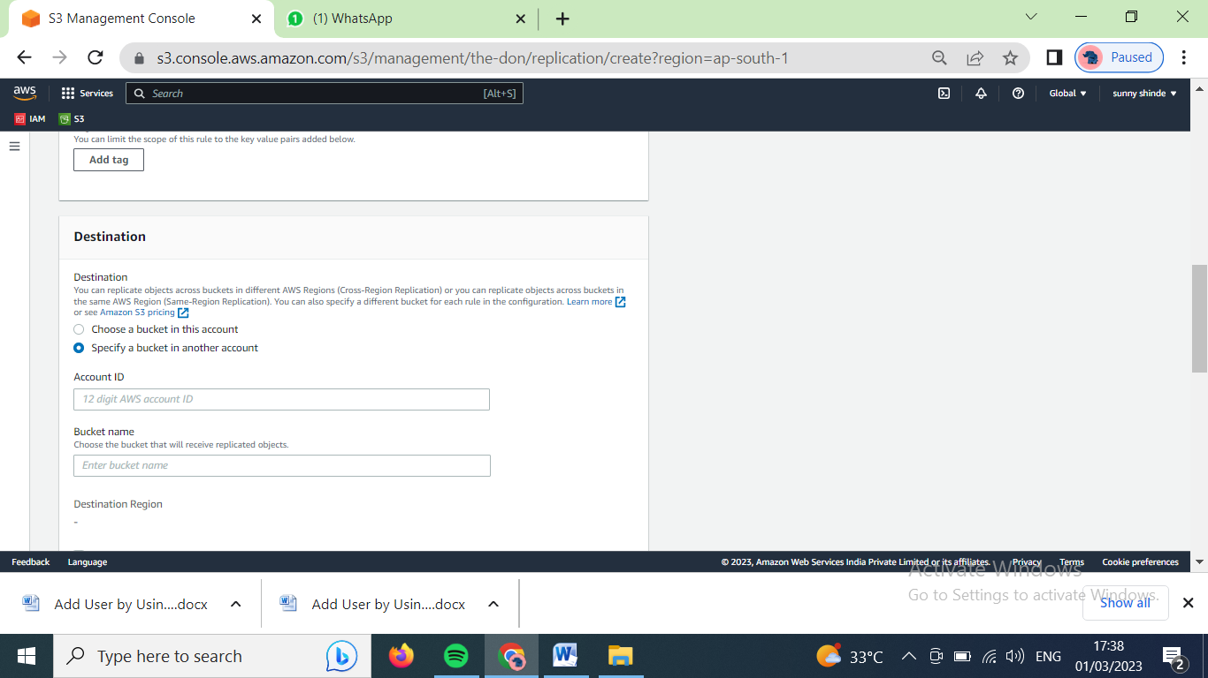

In destination part, select on ‘specify a bucket in another account’

Type the account id and bucket name in that account

Scroll down, Select on ‘create new role’ in IAM role option.

Scroll down, click on save changes.

Then, Select on ‘yes, replicate existing objects’. Click on submit button.

After that replication rule is created and our data from bucket will be copied after some time.

(note : to apply the replication rule, bucket versioning for both buckets i.e. bucket from which data is copied and bucket in which data will copy, must be enable.)